**Summary**

Up to this stage, we have explored how to package an application using Docker and how to bootstrap a cluster using k3s. In the next phase, we need to deploy the packaged application to a Kubernetes cluster.

Kubernetes provides a rich collection of resources that are used to deploy, configure, and manage an application. Some of the widely used resources are:

* Pods - the atomic element within a cluster to manage an application
* Deployments & ReplicaSets - oversees a set of pods for the same application
* Services & Ingress - ensures connectivity and reachability to pods
* Configmaps & Secrets - pass configuration to pods
* Namespaces - provides a logical separation between multiple applications and their resources
* Custom Resource Definition (CRD) - extends Kubernetes API to support custom resources

**Application Deployment**

**Summary**

A **pod** is the anatomic element within a cluster that provides the execution environment for an application. Pods are the smallest manageable units in a Kubernetes cluster. Every pod has a container within it, that executes an application from a Docker image (or any OCI-compliant image). There are use cases where 2-3 containers run within the same pod, however, it is highly recommended to keep the 1:1 ratio between your pods and containers.

All the pods are placed on the cluster nodes. A note can host multiple pods for different applications.

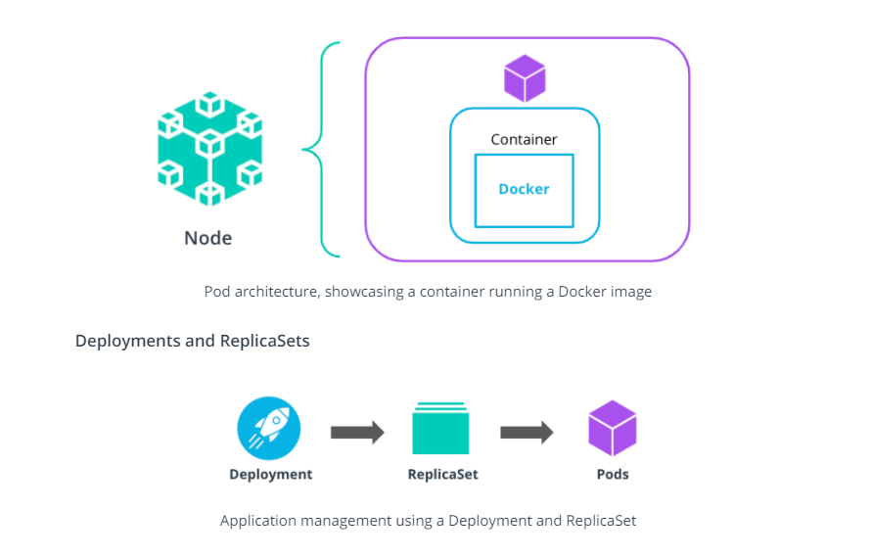

To deploy an application to a Kubernetes cluster, a **Deployment** resource is necessary. A Deployment contains the specifications that describe the desired state of the application. Also, the Deployment resource manages pods by using a **ReplicaSet**. A ReplicaSet resource ensures that the desired amount of replicas for an application are up and running at all times.

To create a deployment, use the kubectl create deployment command, with the following syntax:

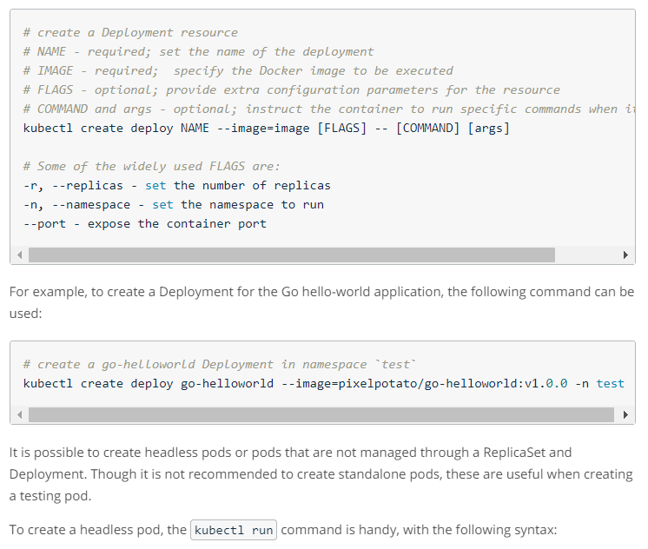

*# create a headless pod*

*# NAME - required; set the name of the pod*

*# IMAGE - required; specify the Docker image to be executed*

*# FLAGS - optional; provide extra configuration parameters for the resource*

*# COMMAND and args - optional; instruct the container to run specific commands when it starts*

kubectl run NAME --image=image [FLAGS] -- [COMMAND] [args...]

*# Some of the widely used FLAGS are:*

--restart - set the restart policy. Options [Always, OnFailure, Never]

--dry-run - dry run the command. Options [none, client, server]

-it - open an interactive shell to the container

For example, to create a busybox pod, the following command can be used:

*# example: create a busybox pod, with an interactive shell and a restart policy set to Never*

kubectl run -it busybox-test --image=busybox --restart=Never

**Rolling Out Strategy**

The Deployment resource comes with a very powerful rolling out strategy, which ensures that no downtime is encountered when a new version of the application is released. Currently, there are 2 rolling out strategies:

* RollingUpdate - updates the pods in a rolling out fashion (e.g. 1-by-1)
* Recreate - kills all existing pods before new ones are created

For example, in this case, we upgrade a Go hello-world application from version 1.0.0 to version 2.0.0:

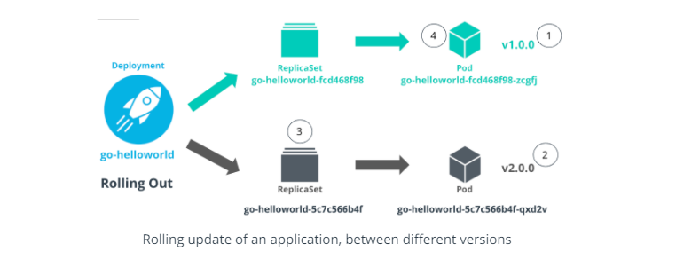

Where:

1. The Go hello-world application is running version v1.0.0 in a pod managed by a ReplicaSet
2. The version of Go hello-world application is set to v2.0.0
3. A new ReplicaSet is created that controls a new pod with the application running in version v2.0.0
4. The traffic is directed to the pod running v2.0.0 and the pod with the old configuration (v1.0.0) is removed

**Application Development Demo**

**Summary**

This demo showcases how an application can be deployed, configured, and managed within a Kubernetes cluster using Deployment, ReplicaSet, and pod resources.

The instructor uses the Go hello-world application in version v1.0.0 and v2.0.0. The difference between these 2 versions is the exposed port by the application. Below are the code snippets for both application versions (you can also refer to the [go-hellowolrd](https://github.com/udacity/nd064_course_1/tree/main/exercises/go-helloworld) application from the course repository):

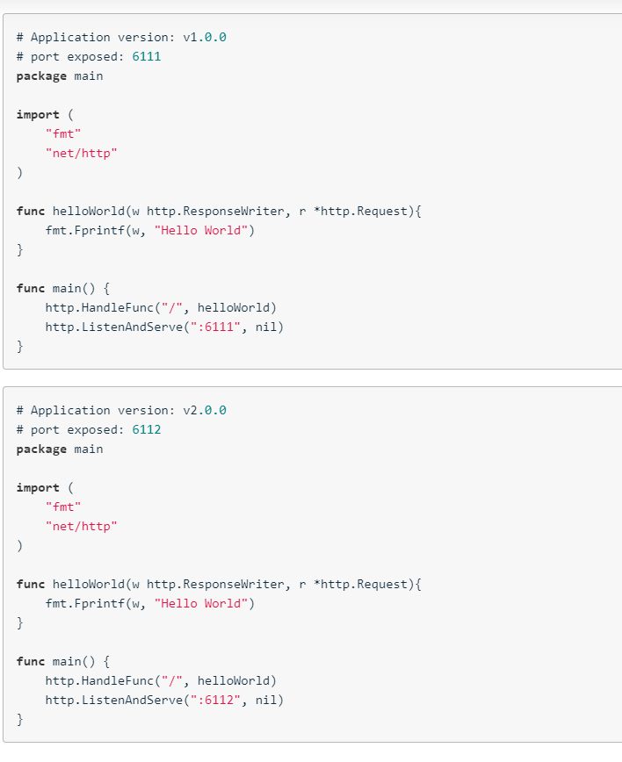

**New terms**

* **Pod** - smallest manageable uint within a cluster that provides the execution environment for an application
* **ReplicaSet** - a mechanism to ensure a number of pod replicas are up and running at all times
* **Deployment** - describe the desired state of the application to be deployed

**Further reading**

Explore the Kubernetes resources in more detail:

* [Kubernetes Pods](https://kubernetes.io/docs/concepts/workloads/pods/)
* [Kubernetes Deployments](https://kubernetes.io/docs/concepts/workloads/controllers/deployment/)
* [Kubernetes ReplicaSets](https://kubernetes.io/docs/concepts/workloads/controllers/replicaset/)
* [Kubernetes RollingOut Strategies](https://kubernetes.io/docs/concepts/workloads/controllers/deployment/#strategy)